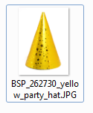

Caption ID of Parent: 116550

Source: BigStockPhoto

Source ID: 262730

Rights Type: Royalty Free

Credit: © Edyta Pawlowska/BigStockPhoto.com

K12 Credit: Yellow party hat. © Edyta Pawlowska/BigStockPhoto.com

RM Assets Embedded: No

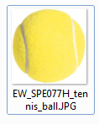

Caption ID of Parent: 113943

Source: Eye Wire

Source ID: SPE077H

Rights Type: Royalty Free

Credit: © Eye Wire

K12 Credit: Yellow tennis ball. © Eye Wire

RM Assets Embedded: No

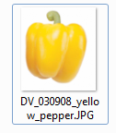

Caption ID of Parent: 114165

Source: Digital Visioin

Source ID: 030908

Rights Type: Royalty Free

Credit: © Digital Vision

K12 Credit: Yellow bell pepper. © Digital Vision

RM Assets Embedded: No

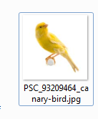

Caption ID of Parent: 1278559

Source: Getty Images

Source ID: 93209464

Rights Type: Royalty Free

Credit: © Eric Isselee/Photos.com/Getty Images

K12 Credit: Canary. © Eric Isselee/Photos.com/Getty Images

RM Assets Embedded: No

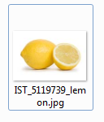

Caption ID of Parent: 175538

Source: iStockphoto.com5119739

Source ID:

Rights Type: Royalty Free

Credit: © jsemeniuk/iStockphoto.com

K12 Credit: Lemons. © jsemeniuk/iStockphoto.com

RM Assets Embedded: No

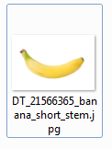

Caption ID of Parent: 1062983

Source: Dreamstime.com

Source ID: 21566365

Rights Type: Royalty Free

Credit: © Prudencio Alvarez/Dreamstime.com

K12 Credit: Banana with short stem. © Prudencio Alvarez/Dreamstime.com

RM Assets Embedded: No

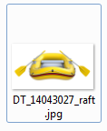

Caption ID of Parent: 379870

Source: Dreamstime.com

Source ID: 14043027

Rights Type: Royalty Free

Credit: © Yudesign/Dreamstime.com

K12 Credit: Inflatable raft. © Yudesign/Dreamstime.com

RM Assets Embedded: No

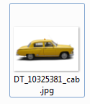

Caption ID of Parent: 219309

Source: Dreamstime.com

Source ID: 10325381

Rights Type: Royalty Free

Credit: © Yuriy Chaban/Dreamstime.com

K12 Credit: Yellow taxi. © Yuriy Chaban/Dreamstime.com

RM Assets Embedded: No

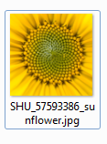

Caption ID of Parent: 1373288

Source: Shutterstock.com

Source ID: 57593386

Rights Type: Royalty Free

Credit: © Eiji Ueda/Shutterstock.com

K12 Credit: Sunflower. © Eiji Ueda/Shutterstock.com

RM Assets Embedded: No